**Slow running query because of memory issue**

**Memory Grant wait**

When a slow running query is detected: identify how long query is running on CPU vs waiting for other resources.

Query is waiting long (but CPU is not being used) – then find the wait type.

Lock-wait, memory wait, IO wait, Network waits, latch waits, scheduler yield waits.

Lets focus on Memory wait.

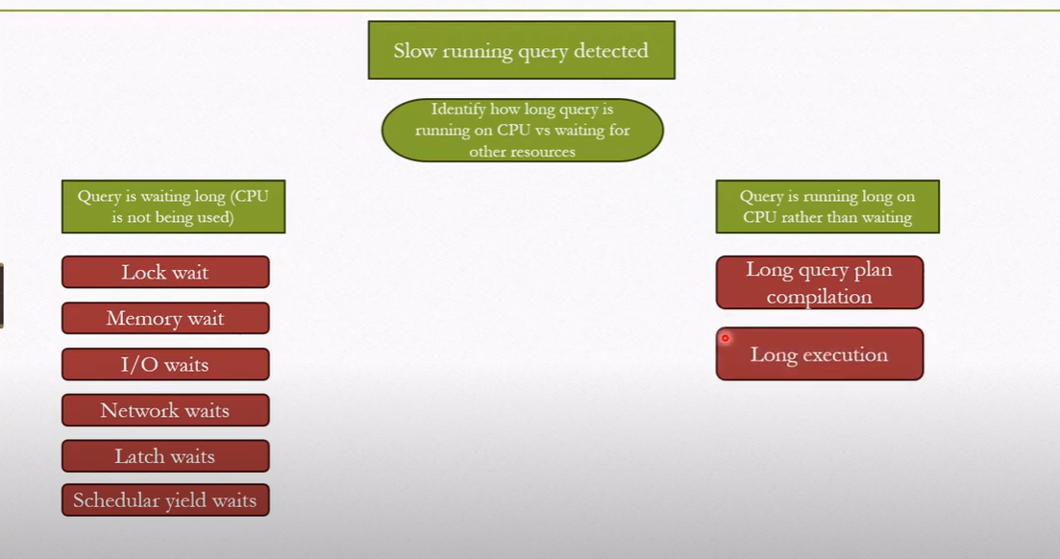

CPU related

Non-CPU related

The process in assigning memory.

Check the query plan – how much memory is granted

Select * from sys.messages

Order by message_id

Right click on select see memory

The below query lists all wait types along with the duration, CPU time and statement

Select

req.session_id

,req.wait_type

,req.total_elapsed_time as duration_ms

,req.cpu_time as cpu_time_ms

,req.total_elapsed_time - req.cpu_time as wait_time

,substring (replace (replace (substring (st.text, (req.statement_start_offset/2) + 1,

((case statement_end_offset

When -1

Then datalength(st.text)

Else req.statement_end_offset

End - req.statement_start_offset)/2) + 1), char(10), ' '), char(13), ' '),

1, 512) as statement_text

From sys.dm_exec_requests as req

Cross apply sys.dm_exec_sql_text(req.sql_handle) AS ST

Order by req.total_elapsed_time Desc;

The below query shows how many sessions the number of granted (grantee_count) and waiters (waiter_count) of a wait-type

Select

Pool_id,

Total_memory_kb

, available_memory_kb

,granted_memory_kb

,grantee_count, waiter_count

, resource_semaphore_id

From sys.dm_exec_query_resource_semaphores rs

How much memory by each session: session_id, requested memory, granted, used, wait time, sql text

Select

Session_id, requested_memory_kb, granted_memory_kb, used_memory_kb,

Queue_id, wait_order, wait_time_ms, is_next_candidate,pool_id, text, query_plan

From sys.dm_exec_query_memory_grants

Cross apply sys.dm_exec_sql_text(sql_handle)

Cross apply sys.dm_exec_query_plan(plan_handle)

If the query runs in the past, no longer now

Use the plan cache history to analyze which query had high memory request

select top 20

SUBSTRING(st.text, (QS.statement_start_offset/2) + 1,

((case statement_end_offset

when -1 then datalength(st.text)

Else QS.statement_end_offset END

- QS.statement_start_offset)/2) + 1) as statement_text

,Convert(decimal (10,2), max_grant_kb /1024.0) as max_grant_mb

,Convert(decimal (10,2), min_grant_kb /1024.0) as min_grant_mb

,Convert(decimal (10,2), (total_grant_kb / execution_count) /1024.0) AS avg_grant_mb

,Convert(decimal (10,2), max_used_grant_kb /1024.0) as max_grant_used_mb

,Convert(decimal (10,2), min_used_grant_kb /1024.0) as min_grant_used_mb

,Convert(decimal (10,2), (total_used_grant_kb / execution_count) /1024.0) AS avg_grant_used_mb

,Convert(decimal (10,2), (total_ideal_grant_kb/ execution_count) /1024.0) AS avg_ideal_grant_mb

,Convert(decimal (10,2), (total_ideal_grant_kb/ 1024.0)) AS total_grant_for_all_executions_mb

,execution_count

from sys.dm_exec_query_stats QS

cross apply sys.dm_exec_sql_text(QS.sql_handle) as ST

Order By max_grant_kb DESC